**Part I**

**Maven Configuration for TestNG:**

Step 1: Firstly we need to

How to create maven project then visit: http://seleniumeasy.com/maven-tutorials

***How to create and run a build in maven to run testng test cases or testng.xml file.***

Precondition: Maven should be installed/configured in eclipse

Step 1: Open command prompt and Locate your pom.xml file, refer below:

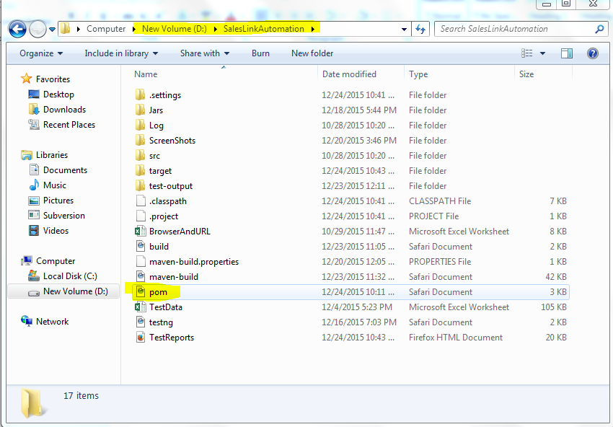

Navigate till pom.xml path as below in command prompt:

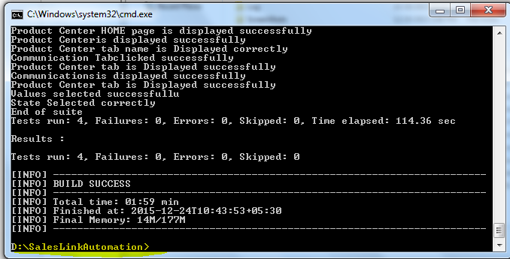

And now issue the command:

mvn ant:ant

After issuing the above command there xml’s file will be created in eclipse as shown below:

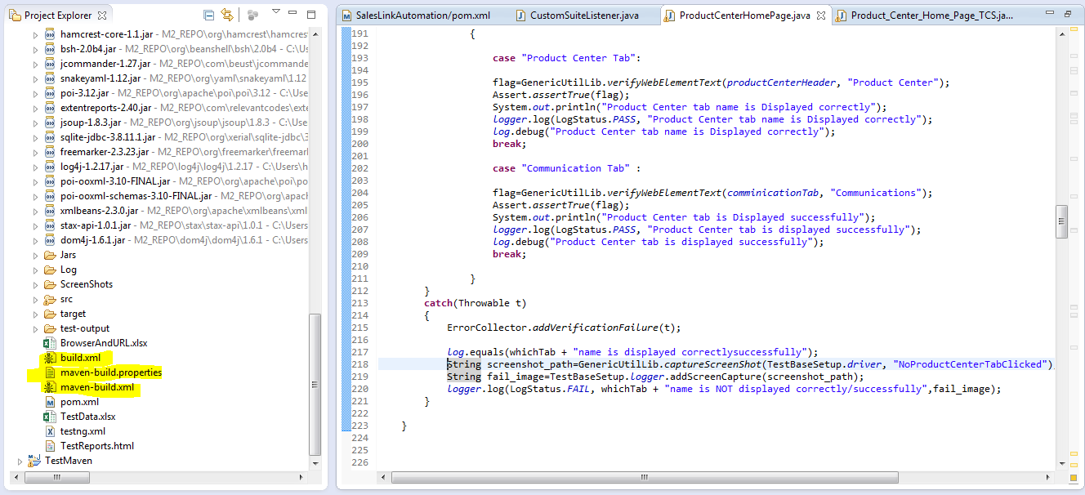

Now configure and update pom.xml file with “maven-surefire-plugin” & “maven-compiler-plugin” as shown below:

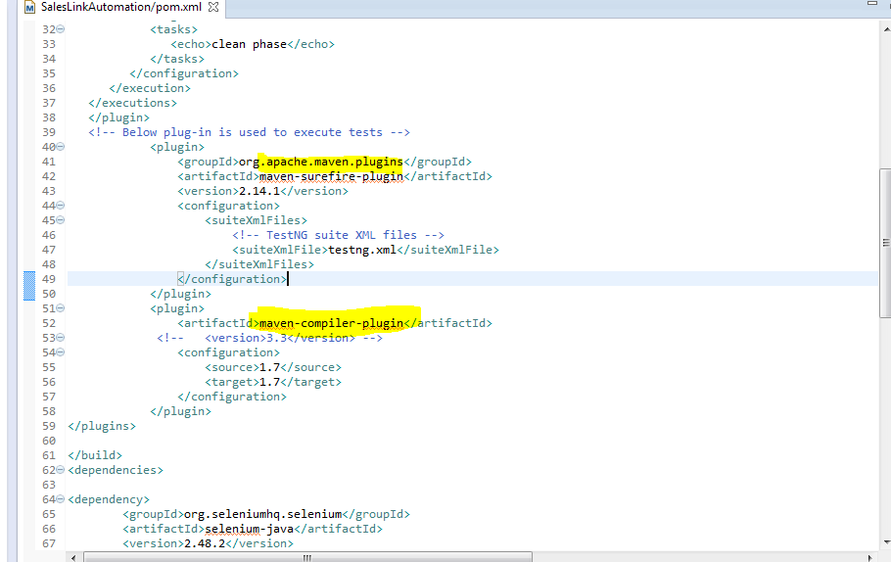

Now clean the project in eclipse: eclipse🡪Project🡪Clean (Note “ This is MANDATORY STEP BEFORE RUNNING THE TESTNG CASES)

Now come back to command prompt, issue the below commands.

1. mvn eclipse: clean

OR

Mvn:clean

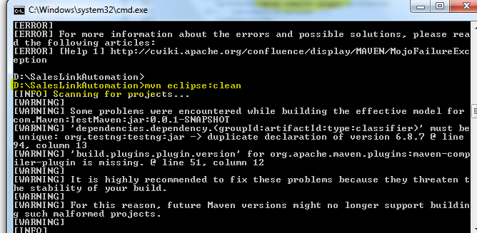

1. mvn eclipse:eclipse

OR

Mvn:compile (also working)

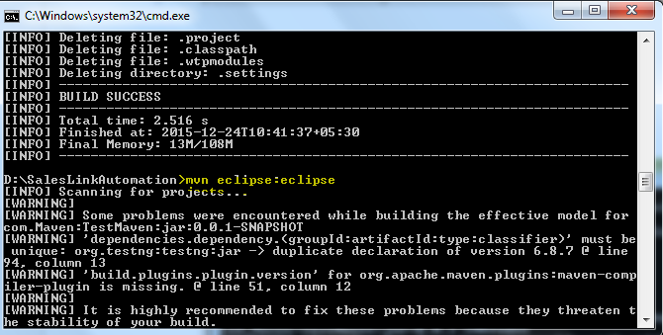

1. mvn test

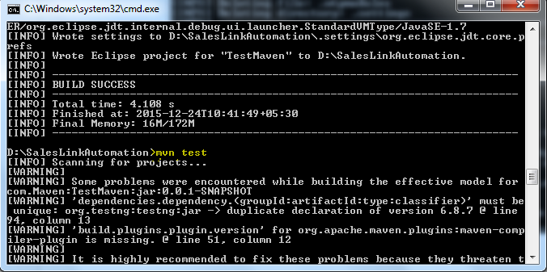

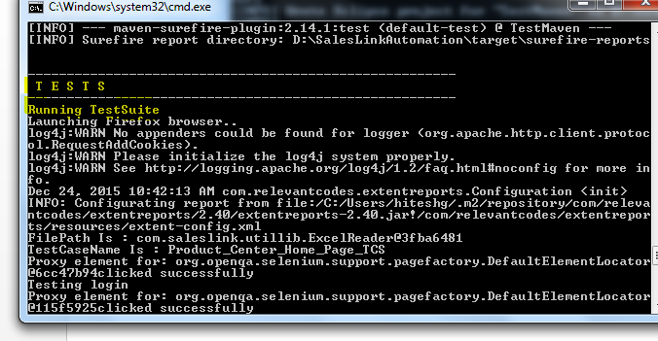

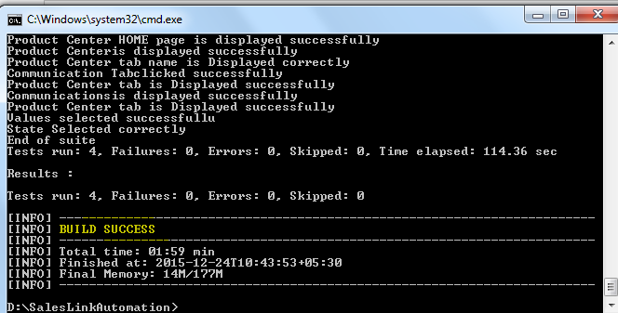

Note: Some time we need to do the below configuration in pom.xml in order to avoid any compilation issues:

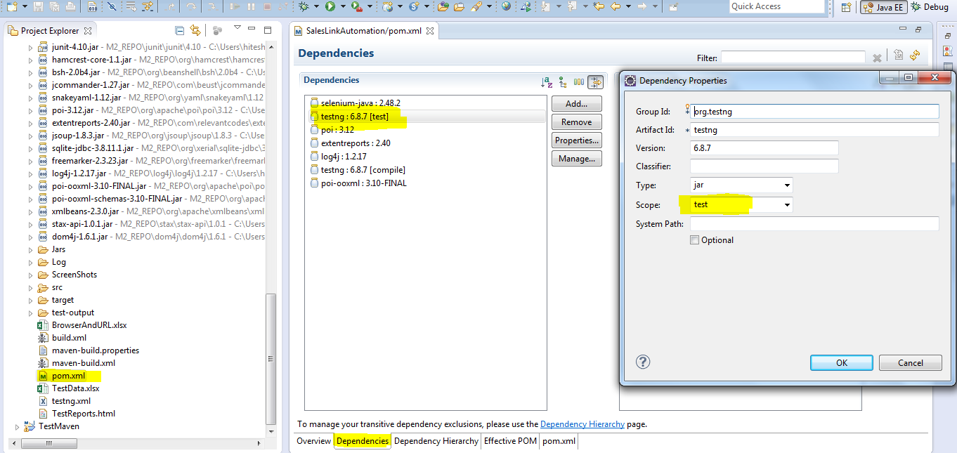

For “build.xml”, ”maven-build.properties”, “maven-build.xml” refer these files code in the folder.

Or build can be cleaned, run from the eclipse as follow as well.

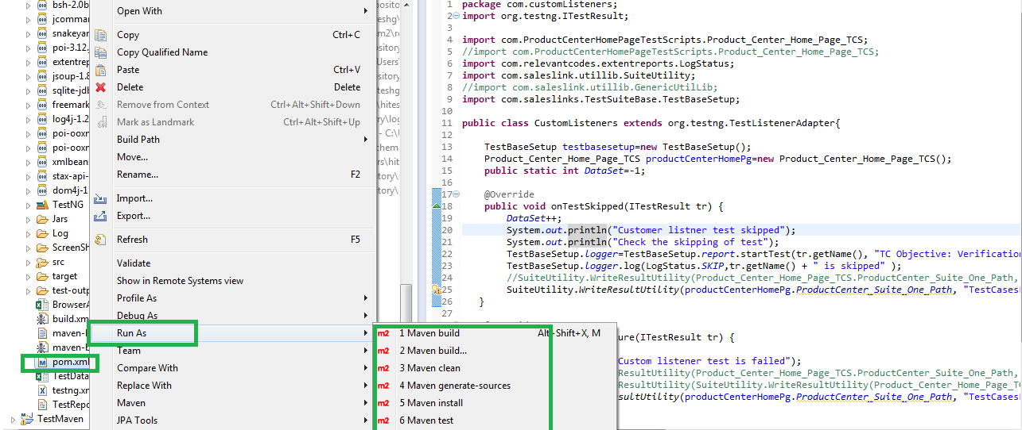

**Now Create a bat and put the following commands to compile, build and run the maven build.**

**Ex:**

d: ( drive where the actual resides and pom.xml resides)

cd ONDECK

mvn clean compile test

**Part II**

Download and Install Jenkins

Step 1: Visit <https://jenkins.io/>

Step 2: Download WAR file

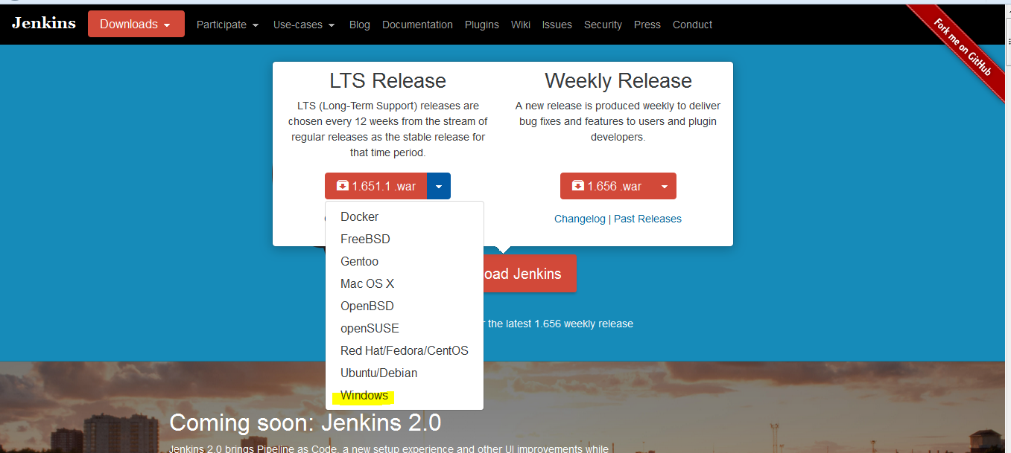

Step 3: Now go where the Jenkins wars is download. E.g in my case it is

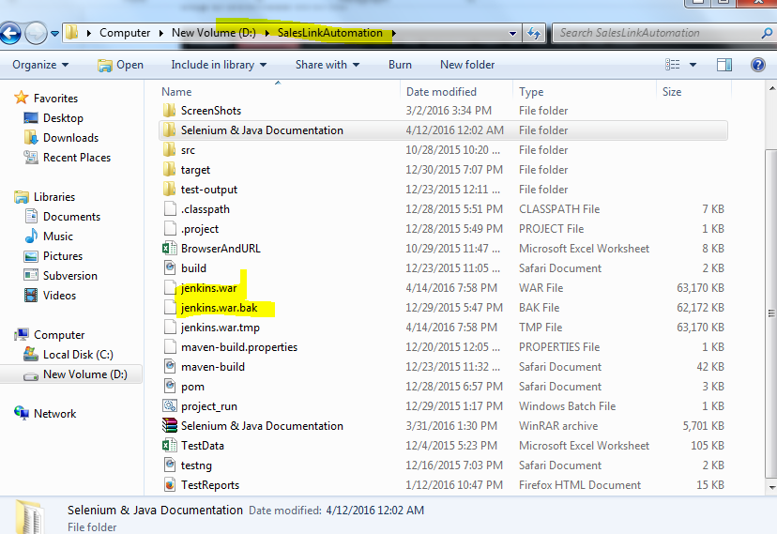

Step 4: Open CMD and reach that path

Step 5: Now start the Jenkins server by issuing the following command

Java –jar jenkins.war

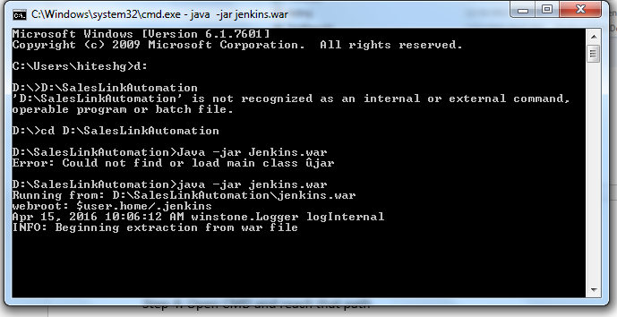

Wait until is shows “Jenkins up and running” as below”

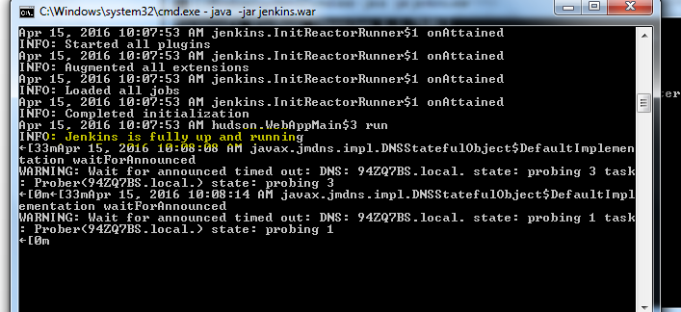

Step 5: Open browser and type “localhost: 8080”

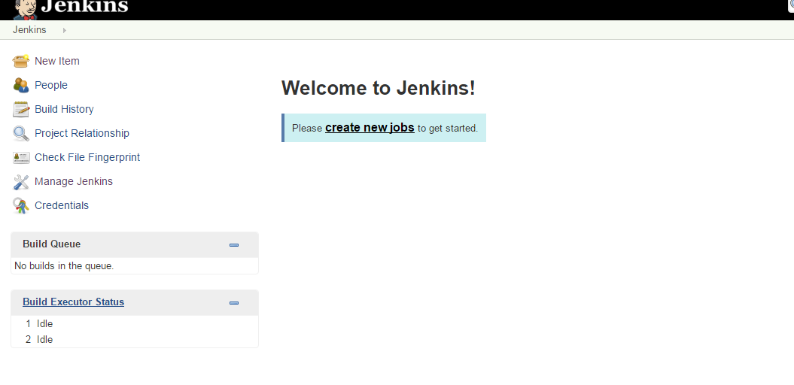

Note: Ignore these steps while running the Jenkins from Eclipse. Just follow the steps from “***Running Jenkins from Eclipse Section” at the end of doc.***

Click on “Manage Jenkins🡪Configure System” and set up the Java and Maven Environment variables as follow:

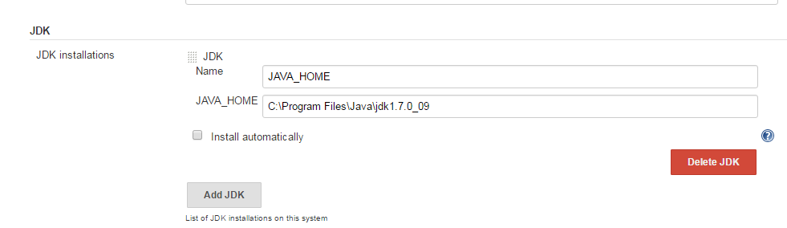

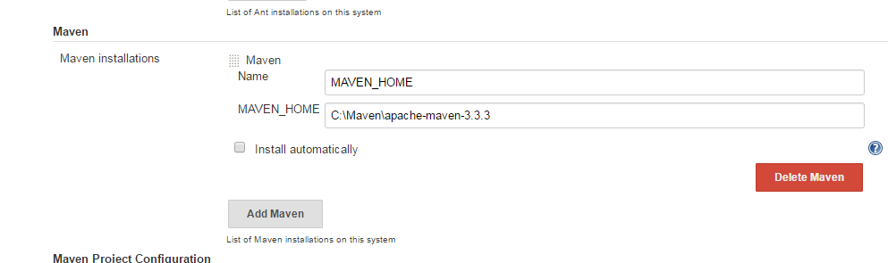

Step 6: Now click on New Item.

Step 7: Select “Freestyle Project”

Provide item name: e.g Ondeck, click ok.

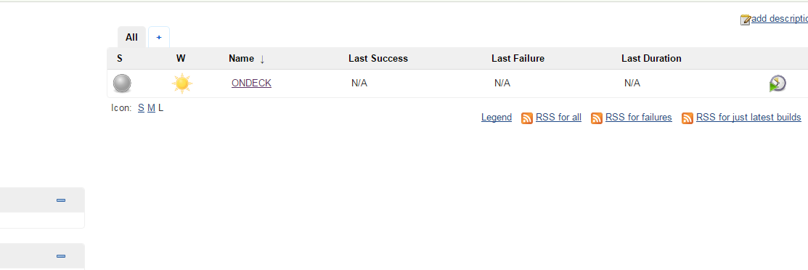

Click configure:

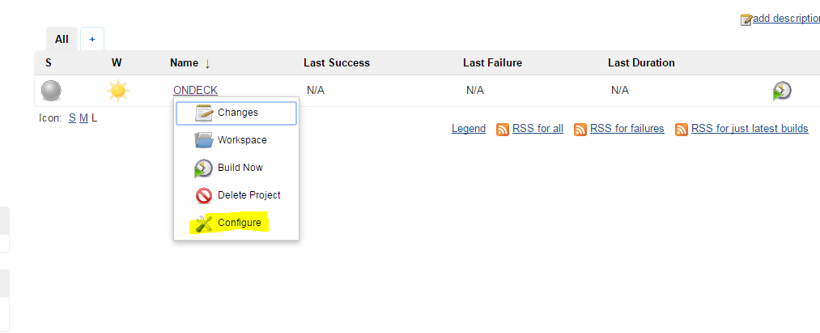

Click Advanced button under “Advance Project Options” section and select “Use Custom Workspace”

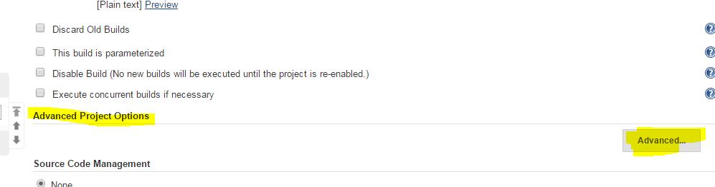

* **Provide directory name (where the project is lying)**

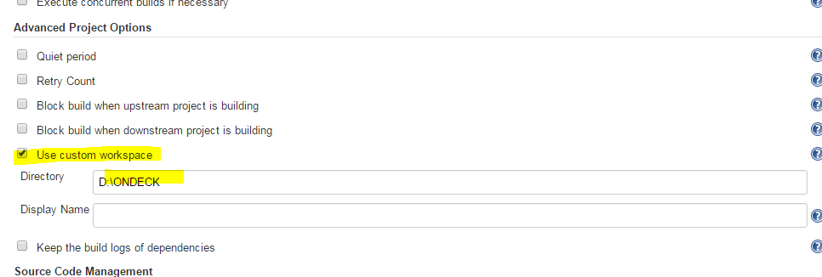

Select “Execute Windows Batch Command.

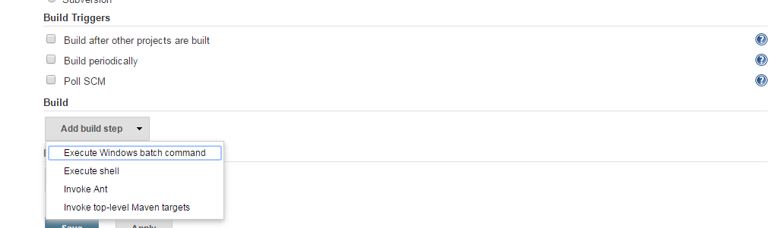

Now provide bat file name as follow:

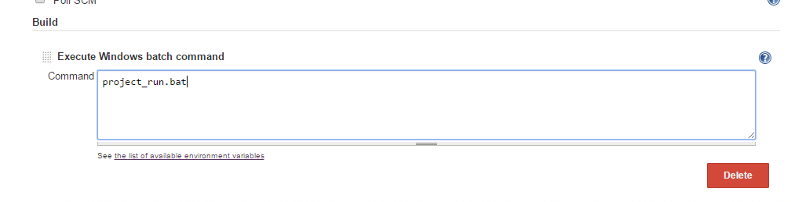

Select Source code management as None

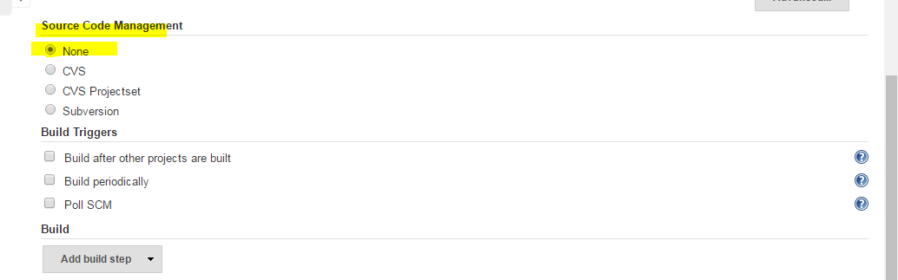

Now set the build periodically at 5: a.m every day:

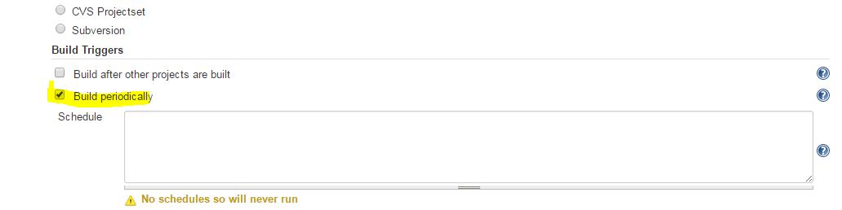

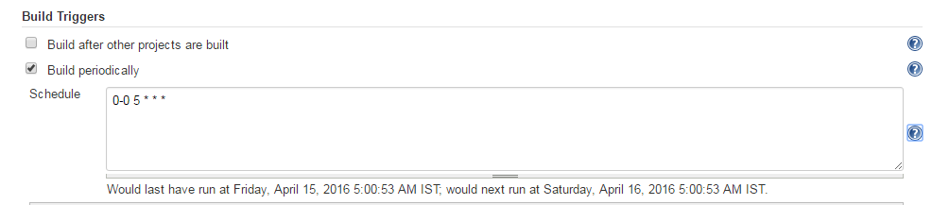

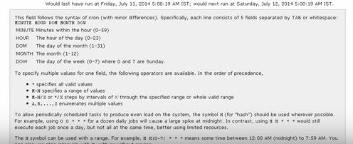

Click save and apply. After that the below window will be displayed.

***Running Jenkins from Eclipse Section***

1. Create a Jenkins build job

Click on New Item

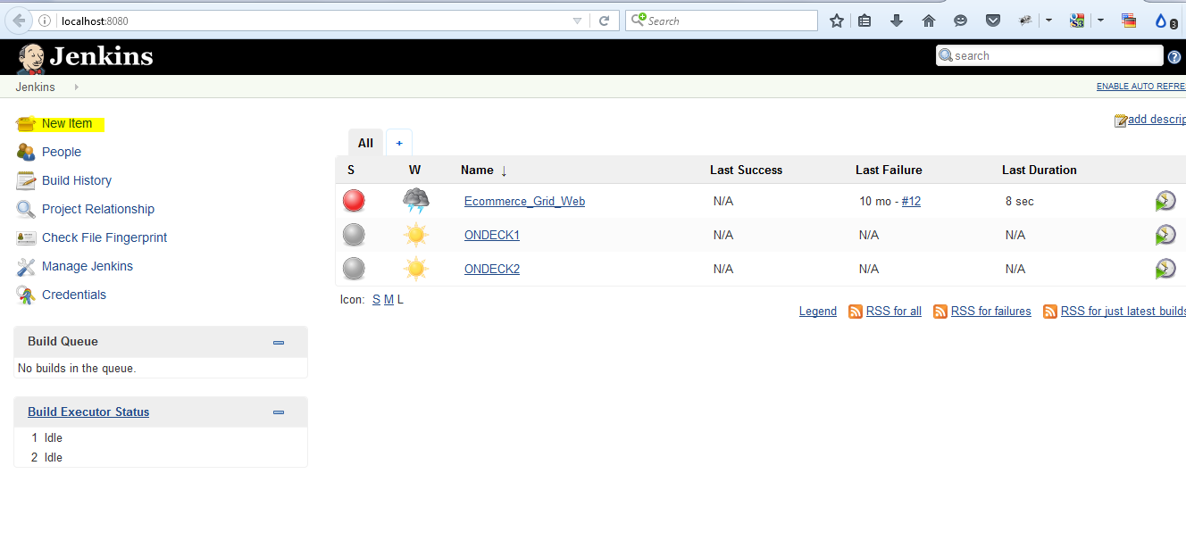

Put a name and select Maven Project

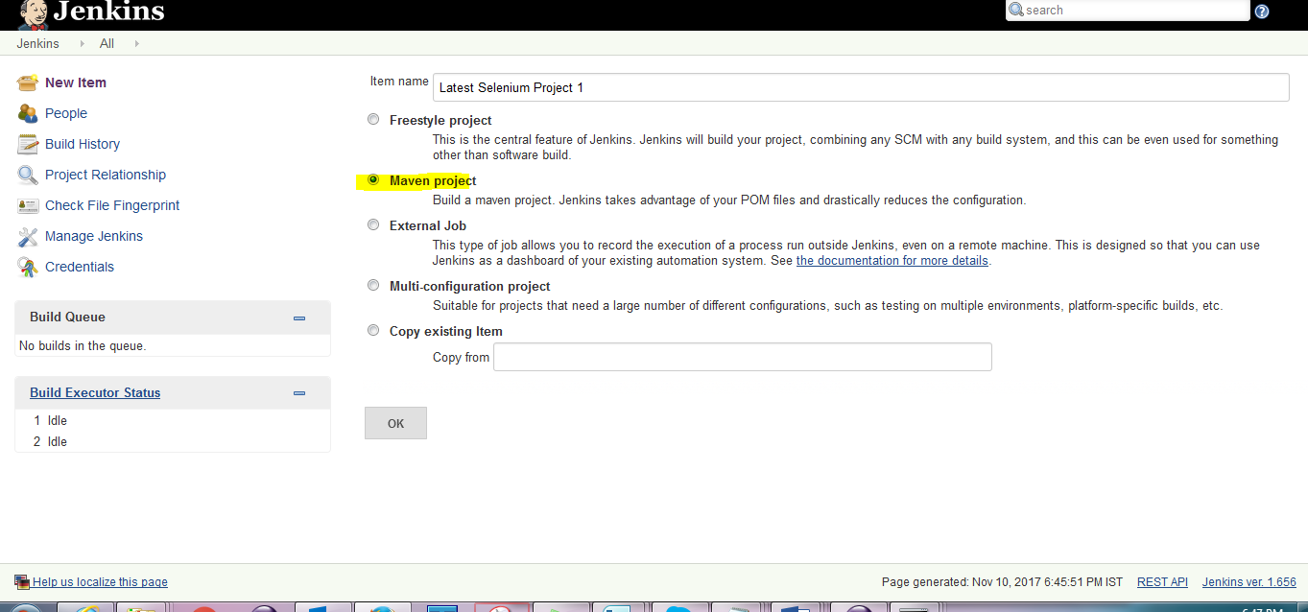

Now, new Jenkins build job will be created and then clicked on this build job and then click on configure link and then scroll down to source code manage and click on ‘Git’ radial button.

Enter

